CS 255 System Design Document Template

UML Diagrams

UML Use Case Diagram

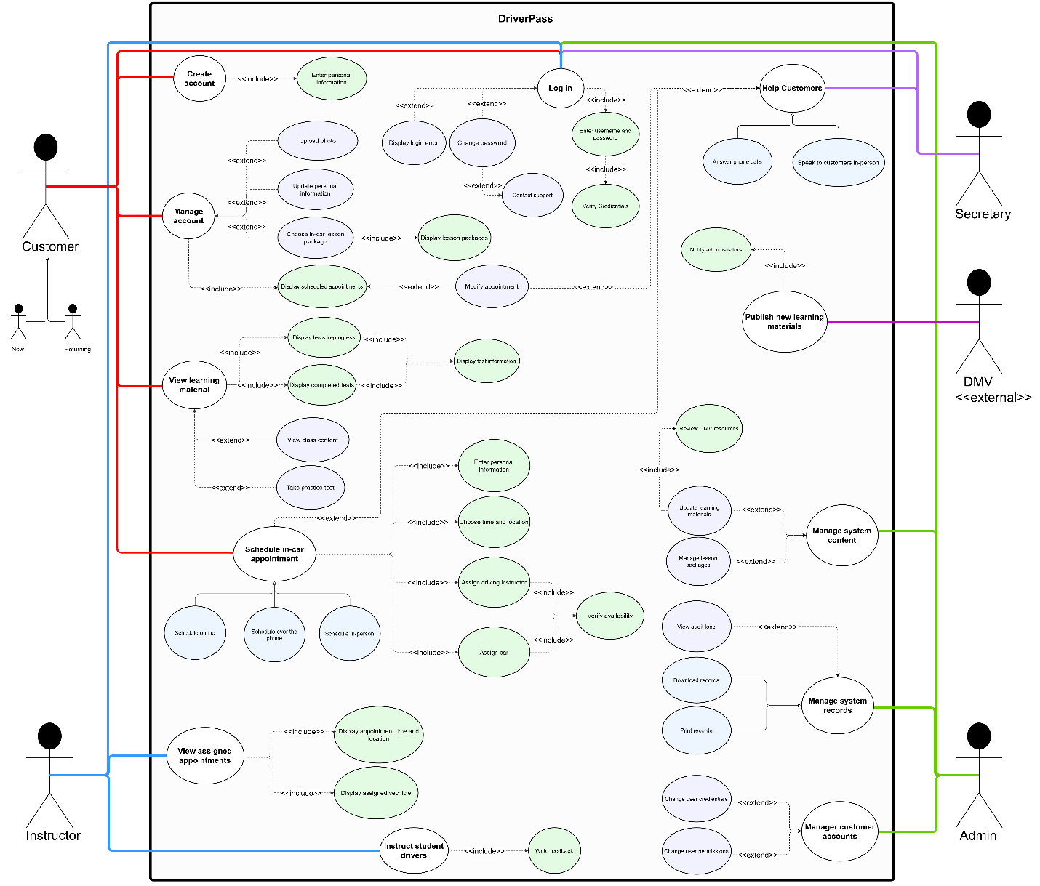

UML Activity Diagrams

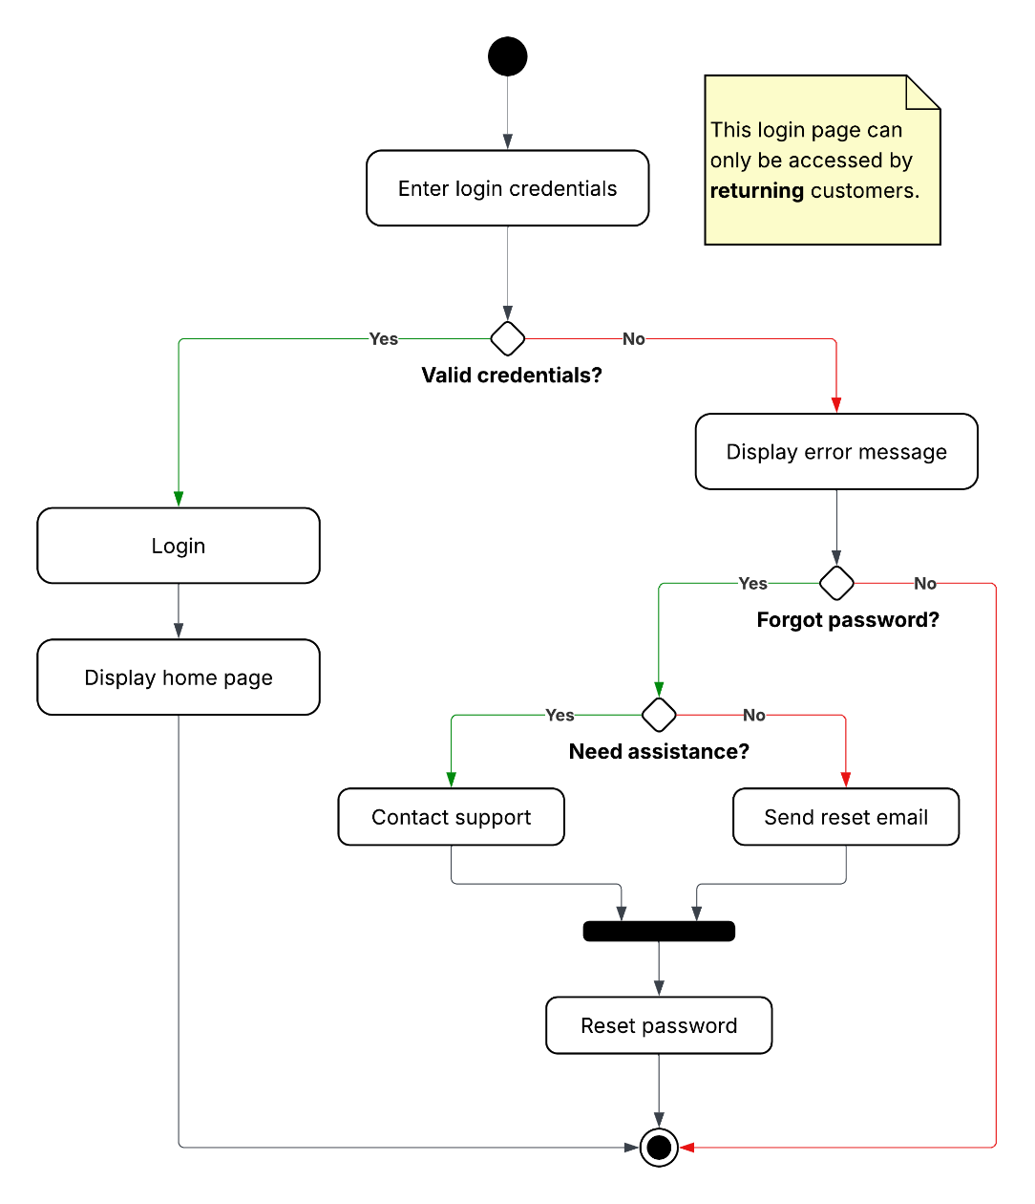
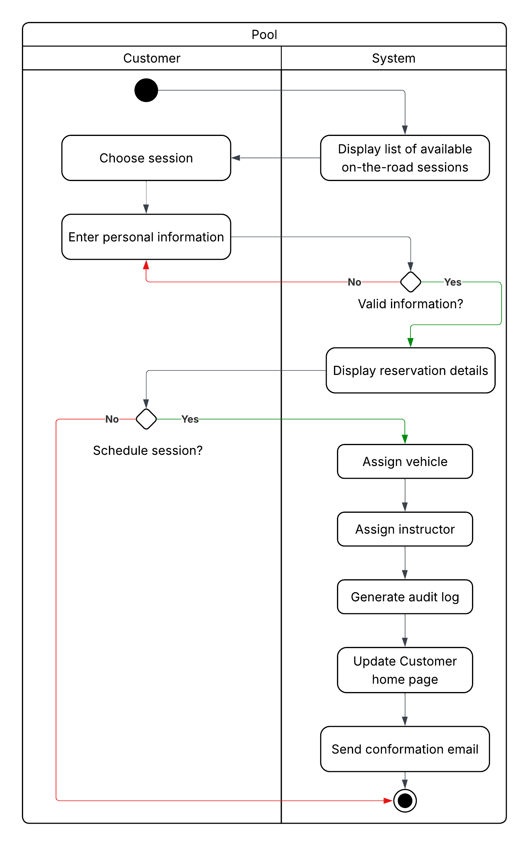

UML Sequence Diagram

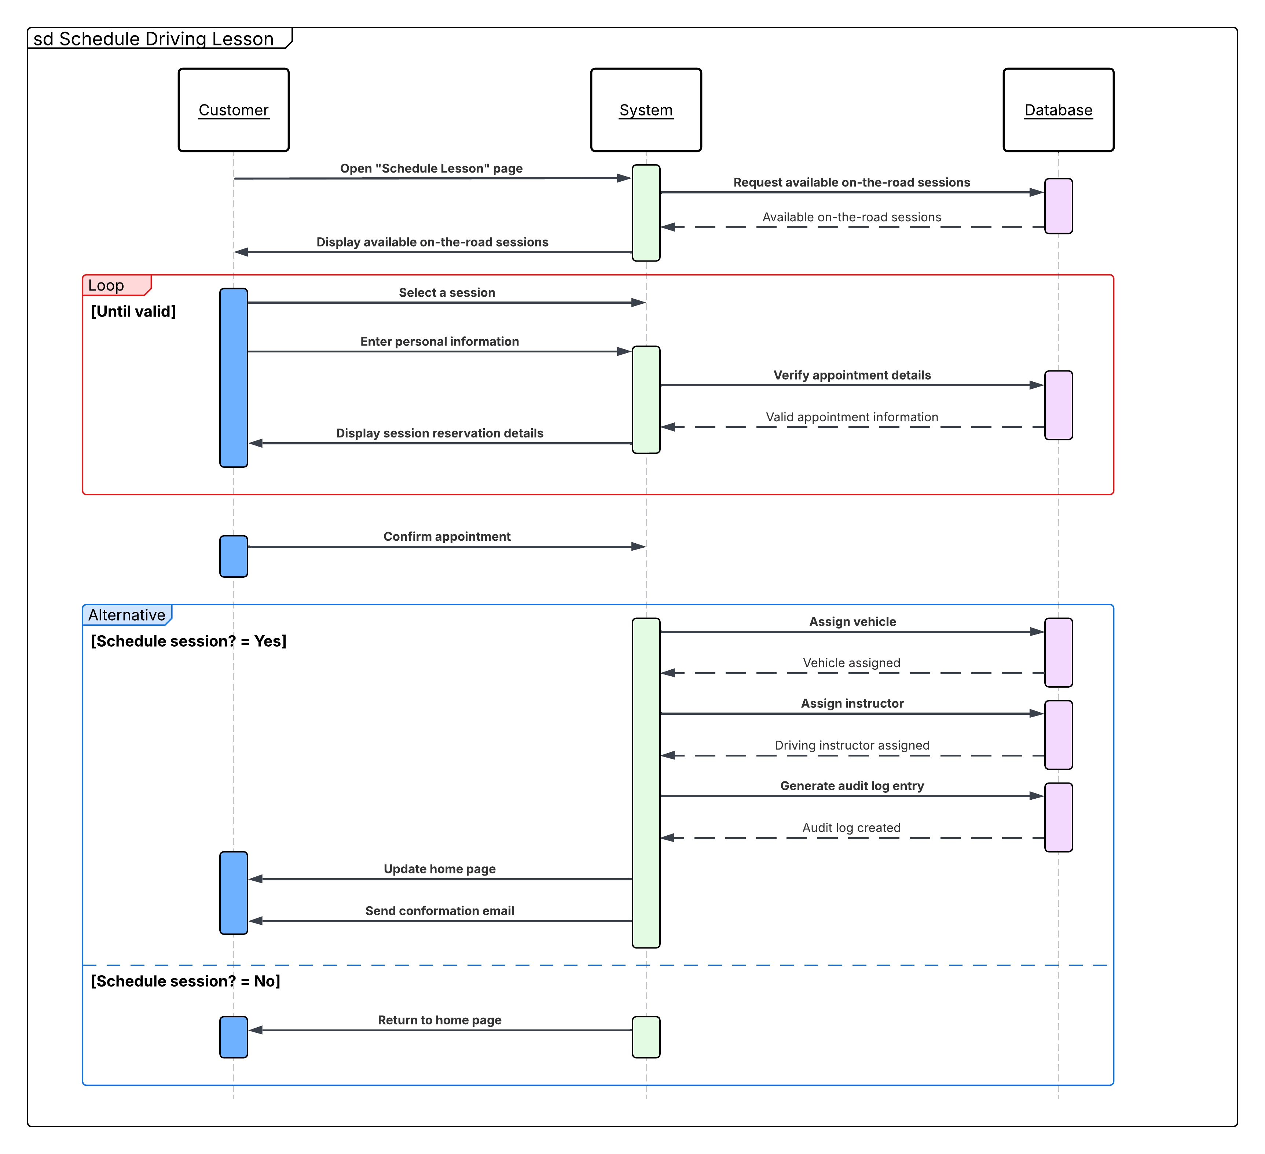

UML Class Diagram
(As permitted by the instructions, methods were excluded from the diagram.)
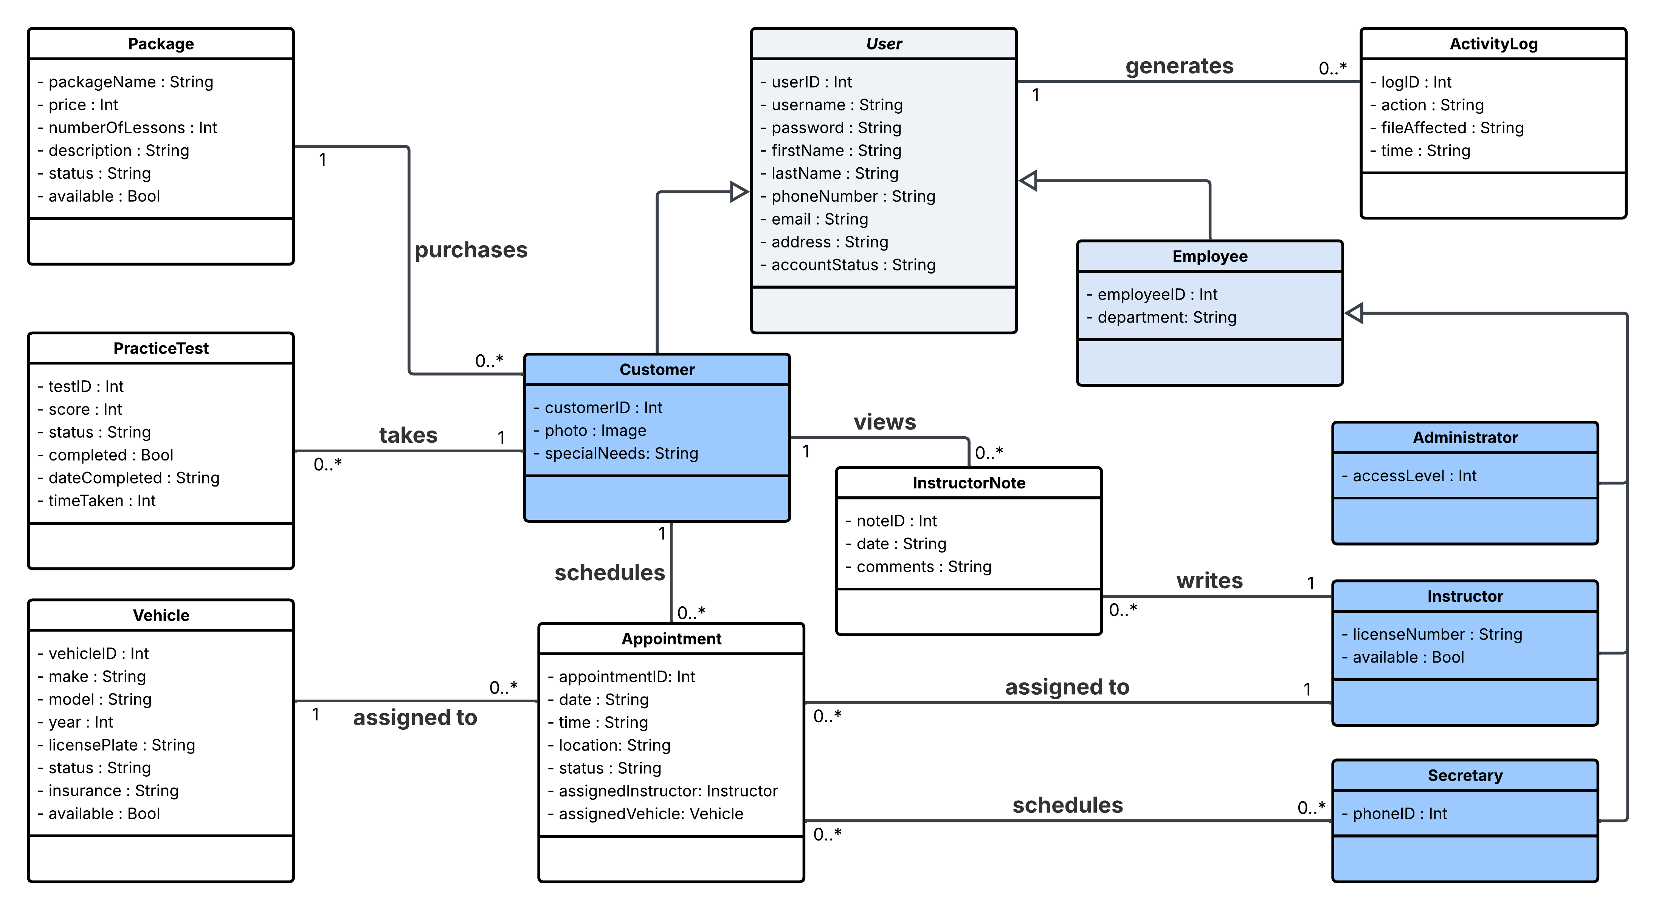

Technical Requirements
Following the client’s requirements, DriverPass will be a web-based cloud-hosted application. As a result, the system requires cloud infrastructure to host the application, store user data, manage appointments, and maintain learning materials. The cloud-hosting service provider should provide both web hosting and database services while also offering tools for managing system security, backups, and availability. Since DriverPass is a web-based system, users will need an internet connection and a compatible device with a modern web browser, such as a computer, tablet, or mobile device.
On the backend, the system requires a relational database management system and application services to support user authentication, role-based access control, appointment scheduling, online learning materials, practice tests, reporting, and activity logging. The system should also support API integrations with third-party services, such as payment providers like Stripe or PayPal, to securely process customer transactions. Additionally, DriverPass may require a custom API integration with the DMV to automatically retrieve and update practice test information, ensuring learning materials remain accurate and current.
Development of the DriverPass application will require tools such as an integrated development environment (IDE), version control software like Git, and testing tools to support implementation, maintenance, and future updates. Because the system is web-based and developed using technologies such as HTML, CSS, and JavaScript, development can be performed on any compatible operating system without requiring a specific platform.

